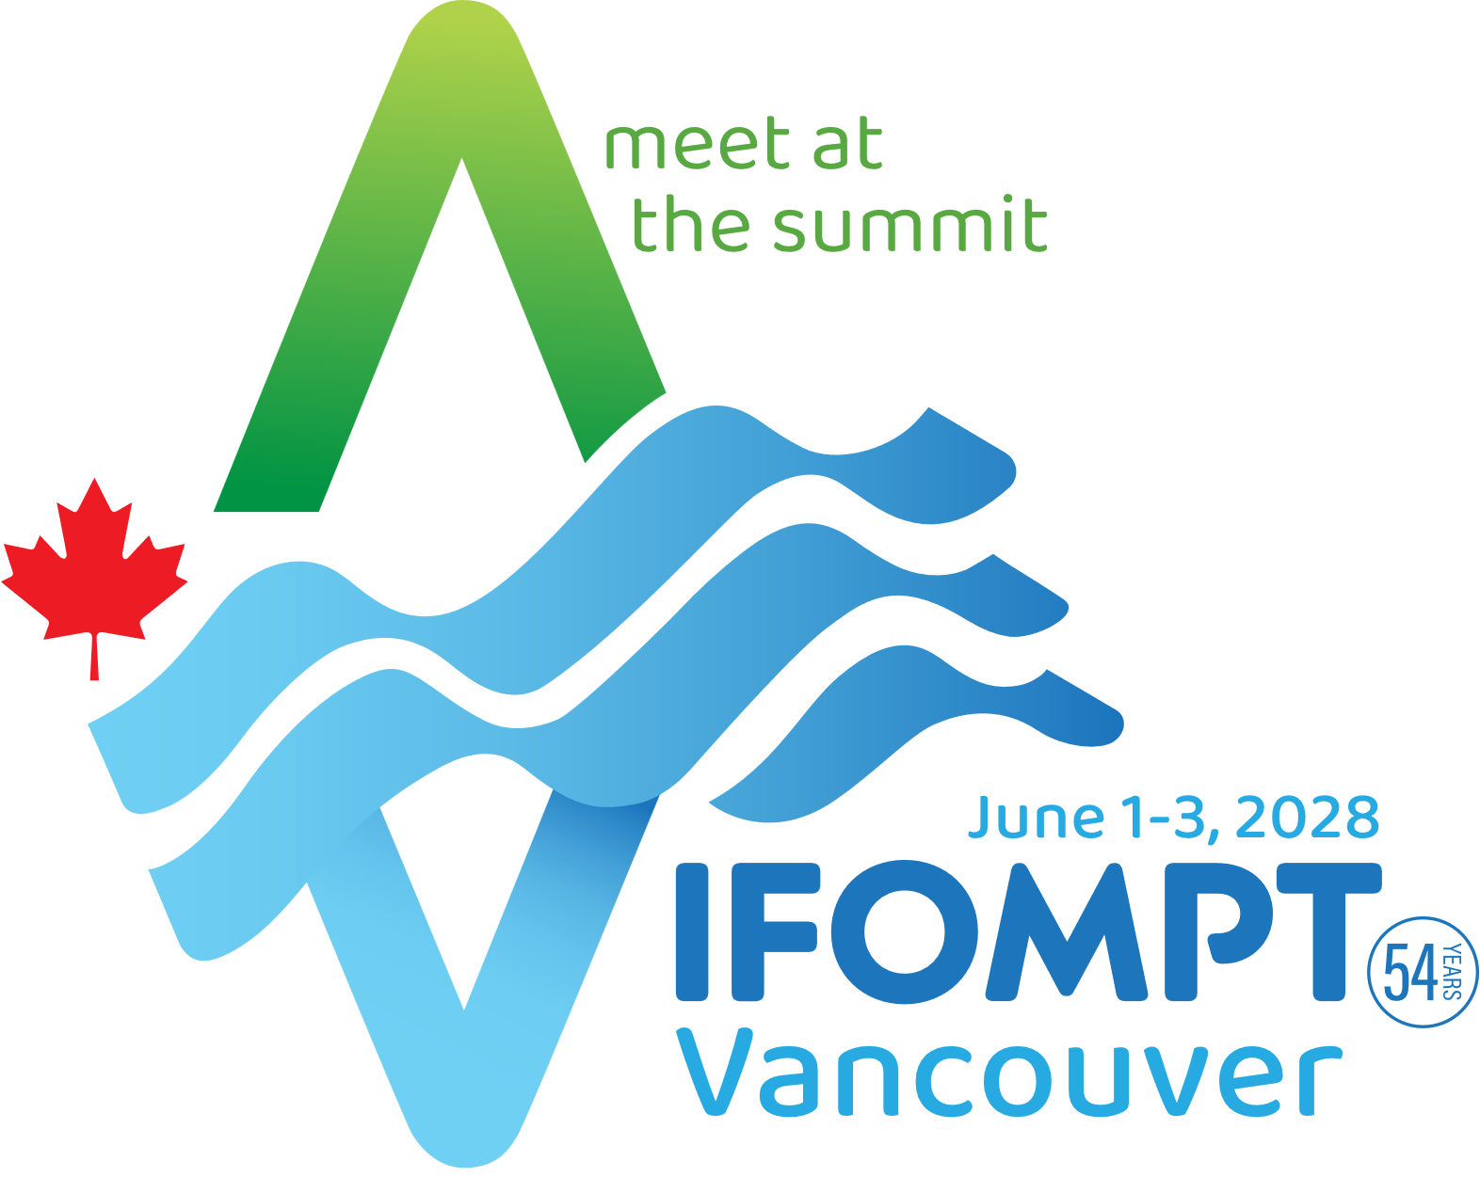
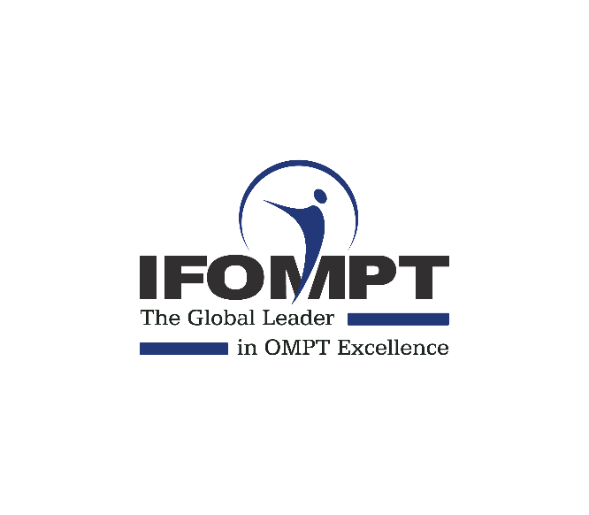

IFOMPT VANCOUVER 2028 Competition – Rules

Eligibility: The competition is open to all registered Physiotherapists/Physical Therapists and Physiotherapy students from anywhere in the world.

Theme: The theme of the competition is “Manual & MSK Masters Showcase”
Participants must adhere to this theme in their video submissions.

Video Entry: All submissions must be in the form of a video. Participants should create a video to showcase Manual/MSK Physiotherapy of no longer than 90 seconds.
Only videos posted on Facebook, Instagram and sent via email will be considered.

Original Content: All video entries must be original works created by the participants. Plagiarism or the use of copyrighted material without proper permission will lead to disqualification.

Competition Period: The competition will be open from 30 April – 31 May (midday GMT+9)
Competition Launch: The competition will officially launch on 30 April 2025.
Prizes: The competition offers one conference registration to attend the IFOMPT 2028 conference in Vancouver . These prizes do not cover accommodation, travel, food, beverages, or any other expenses incurred by conference participants. The prizes are non-transferable and cannot be exchanged for monetary compensation.

Submission Guidelines: Participants must follow the submission guidelines provided on the official IFOMPT website (www.ifompt.org). These guidelines will include details on format, size, and method of submission.

Entry Deadline To be considered for the conference registration prize, participants must submit their entries before midday 31 May 2025 (GMT+9)

Judging Panel: A judging panel appointed by IFOMPT will evaluate all video entries based on specific criteria.

Judging Criteria: Entries will be judged based on the following criteria:

- Meeting all entry requirements.
- Audio/Visual (Usability) quality.
- Freshness of the idea and creativity.
- Capturing the competition theme effectively.
- Compelling presentation, performance, or message.
- Attention to detail, including production, props, location, etc.
- Scoring: Each entry will be independently scored by the judging panel based on the above criteria. The total score for each entry will be out of 30 points.

Winner Announcement: The winner of the conference registration prize will be announced at WPT Congress on 31 May 2025 during the afternoon tea break at the IFOMPT stand.

Ethical Standards: Participants must adhere to the highest ethical standards in their submissions, ensuring that all content is respectful, professional, and does not violate any confidentiality or privacy agreements.

Disqualification: IFOMPT reserves the right to disqualify any entry that violates the competition rules or IFOMPT's code of ethics.

Rights and Usage: By participating in the competition, entrants grant IFOMPT the right to use and share their videos for marketing, promotional, and educational purposes, with proper attribution.

Conduct Guidelines: Participants must exhibit respectful and professional behaviour throughout the competition process. Any instances of misconduct may lead to disqualification.

Decision Finality: All decisions made by IFOMPT or the judging panel regarding the competition are final and binding.

By entering the IFOMPT Vancouver 2028 Competition, all participants agree to comply with these rules and regulations. The competition aims to celebrate and showcase the excellence and value of Manual / MSK Physiotherapy and encourage creativity and innovation among physiotherapists worldwide.

